RESTAURANT/RETAIL OUTLET
ADDRESS
CITY, STATE ZIP
Dear Sir or Madam: DATE
I am writing to you as a frequent visitor to your [restaurant/retail outlet], to request that you offer meat, dairy and or egg products that are certified by A Greener World (AGW), a non-profit, third-party certifier and home of North America’s leading labels—Certified Animal Welfare Approved by AGW, Certified Grassfed by AGW and Certified Non-GMO by AGW. AGW certifies and promotes verified farming practices & encourages food choices that deliver positive impacts for the environment, society, and animals.
More and more people just like me are confused by misleading food labels such as “natural,” “free range,” and “antibiotic free.” We are seeking verification that the foods we buy are produced with the health of the environment, animals, and our families in mind—and we want to be able to enjoy honestly labeled meat, dairy and eggs from our favorite restaurants and retail outlets.
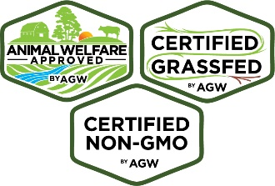
A Greener World’s certifications are recognized as the world’s leading food labels: A respected industry analyst, the Hartman Group, recently found that Certified Animal Welfare Approved(AWA) by A Greener World has the highest impact on purchasing of ANY food label, at 77%. Here is some more information about the labels I trust:
Certified Animal Welfare Approved by AGW is a third-party certification and food label that lets consumers know animals are raised outdoors on pasture or range in accordance with the highest animal welfare standards in the U.S. and Canada, using sustainable agriculture methods on an independent farm. Farms may pursue certification on a species-by-species basis and are audited annually to ensure compliance. AGW also offers optional additional accreditations for AWA farmers: Certified Grassfed by AGW, for animals raised with a 100% grassfed feeding protocol, and Certified Non-GMO by AGW, for animals raised without genetically engineered feed, supplements or ingredients.
If you would like to know more or have questions regarding the sourcing of certified meat, dairy and eggs, please visit www.agreenerworld.org and contact the AGW main office at (202) 546-5292 or info@agreeenerworld.org.

Thank you for considering my request.

Sincerely,

