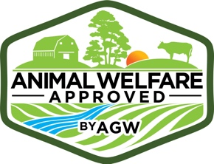
Chicks, Poults, Ducklings and Goslings Record for Movements
This form must be completed for every batch of chicks, poults, ducklings
or goslings that are moved.
MOVEMENT RECORD
Farm name
Source of birds (hatchery, etc.) with address and contact details
Date birds ordered

Number and type of birds ordered
Proposed date of movement
CALL TO HATCHERY PRE MOVEMENT
Date of call
Contact person
Proposed date and time of dispatch
Confirmation that birds will at all times be transported in temperature controlled and air controlled vehicles
Proposed methods of delivery (including vehicle types for the whole journey, e.g. truck then airplane then car)
Points of transfer including address (e.g. hatchery takes birds to My Local Airport at 1000 Airport Drive, My Town, My State)

ACTUAL MOVEMENT
Date birds arrived
Time birds arrived
Number of birds arrived total
Number of birds arrived dead
Number of birds arrived sick or injured
Number of healthy, live birds
Times and places of transfer of birds (e.g. hatchery arrived at airport at 11.00am flight to next airport arrival at 3.00pm)
Any differences or delays from the originally proposed route

