RESTAURANT/RETAIL OUTLET
ADDRESS
CITY, STATE ZIP
Dear Sir or Madam: DATE
As a frequent customer I’m writing to ask you to carry meat, dairy and egg products that are certified by A Greener World (AGW). AGW is home of North America’s leading food labels, including Certified Animal Welfare Approved by AGW, Certified Grassfed by AGW and Certified Non-GMO by AGW.
More and more people just like me are confused by misleading food labels such as “natural,” “free range” and “antibiotic free.” We are seeking verification that the foods we buy actually deliver sustainability, and we want to be able to enjoy honestly labeled meat, dairy and eggs from our favorite restaurants and retail outlets. AGW offers a range of third-party audited food labels that I trust, including:
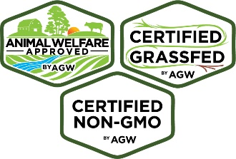
- Certified Animal Welfare Approved by AGW ensures animals are raised outdoors on pasture or range according to the highest animal welfare standards for their entire lives. Certified AWA by AGW has the highest impact on consumer purchasing of any food label, according to a recent survey by The Hartman Group.
- Certified Grassfed by AGW, for ruminant species that are Certified AWA by AGW and raised with a 100% grassfed feeding protocol. The only grassfed label to guarantee animal welfare, pasture-based management and sustainability.
- Certified Non-GMO by AGW, for food products and Certified AWA by AGW meat, dairy, eggs and fiber produced without genetically engineered feed, supplements or ingredients. The most meaningful non-GMO label on the market and the only one to ensure animal welfare.
A Greener World’s staff is dedicated to making certified products available everywhere. For more information and help sourcing certified products, please visit www.agreenerworld.org, call 1-800-373-8806 or email info@agreeenerworld.org.

Thank you for considering my request and I look forward to purchasing AGW-certified products from you!

Sincerely,

SIGNATURE

